TC-CMS-004
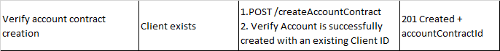
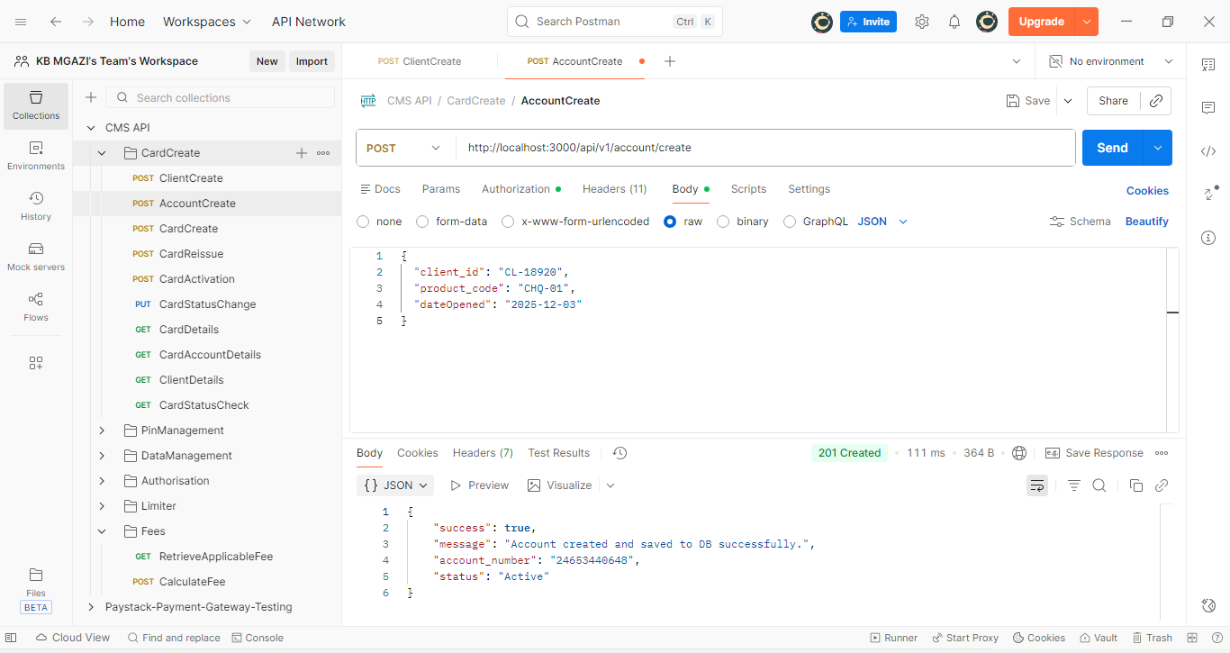
Request:
{
"client_id": "CL-18920",
"product_code": "CHQ-01",
"dateOpened": "2025-12-03"
}

Response:
{
"success": true,
"message": "Account created",
"account_number": "24653440648",
"status": "Active"
}

Account Successfully Created
